REPORT FOR TASK 5, VARIANT 8

1. Scalar-valued:

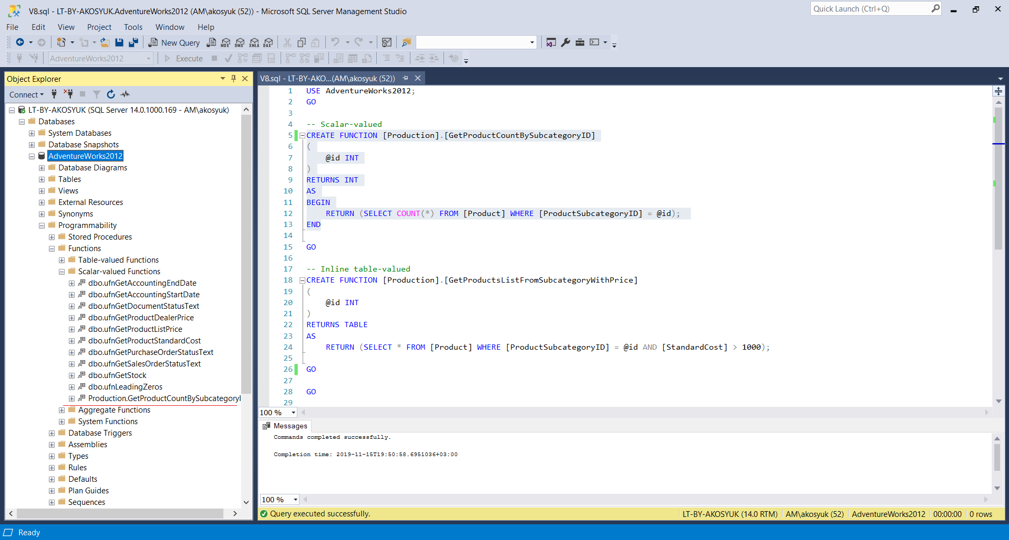

2. Inline table-valued:

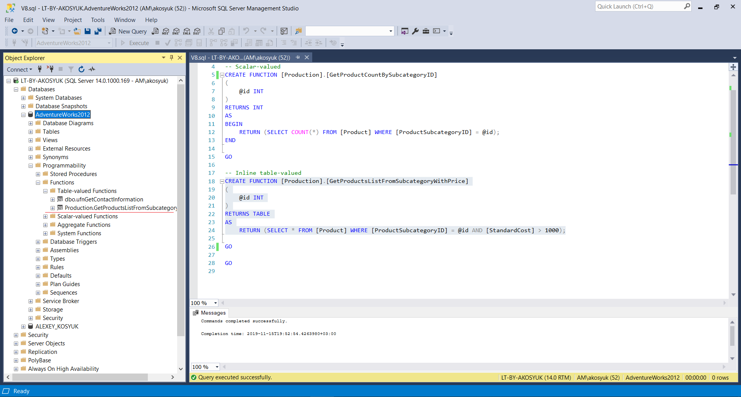

3. CROSS APPLY:

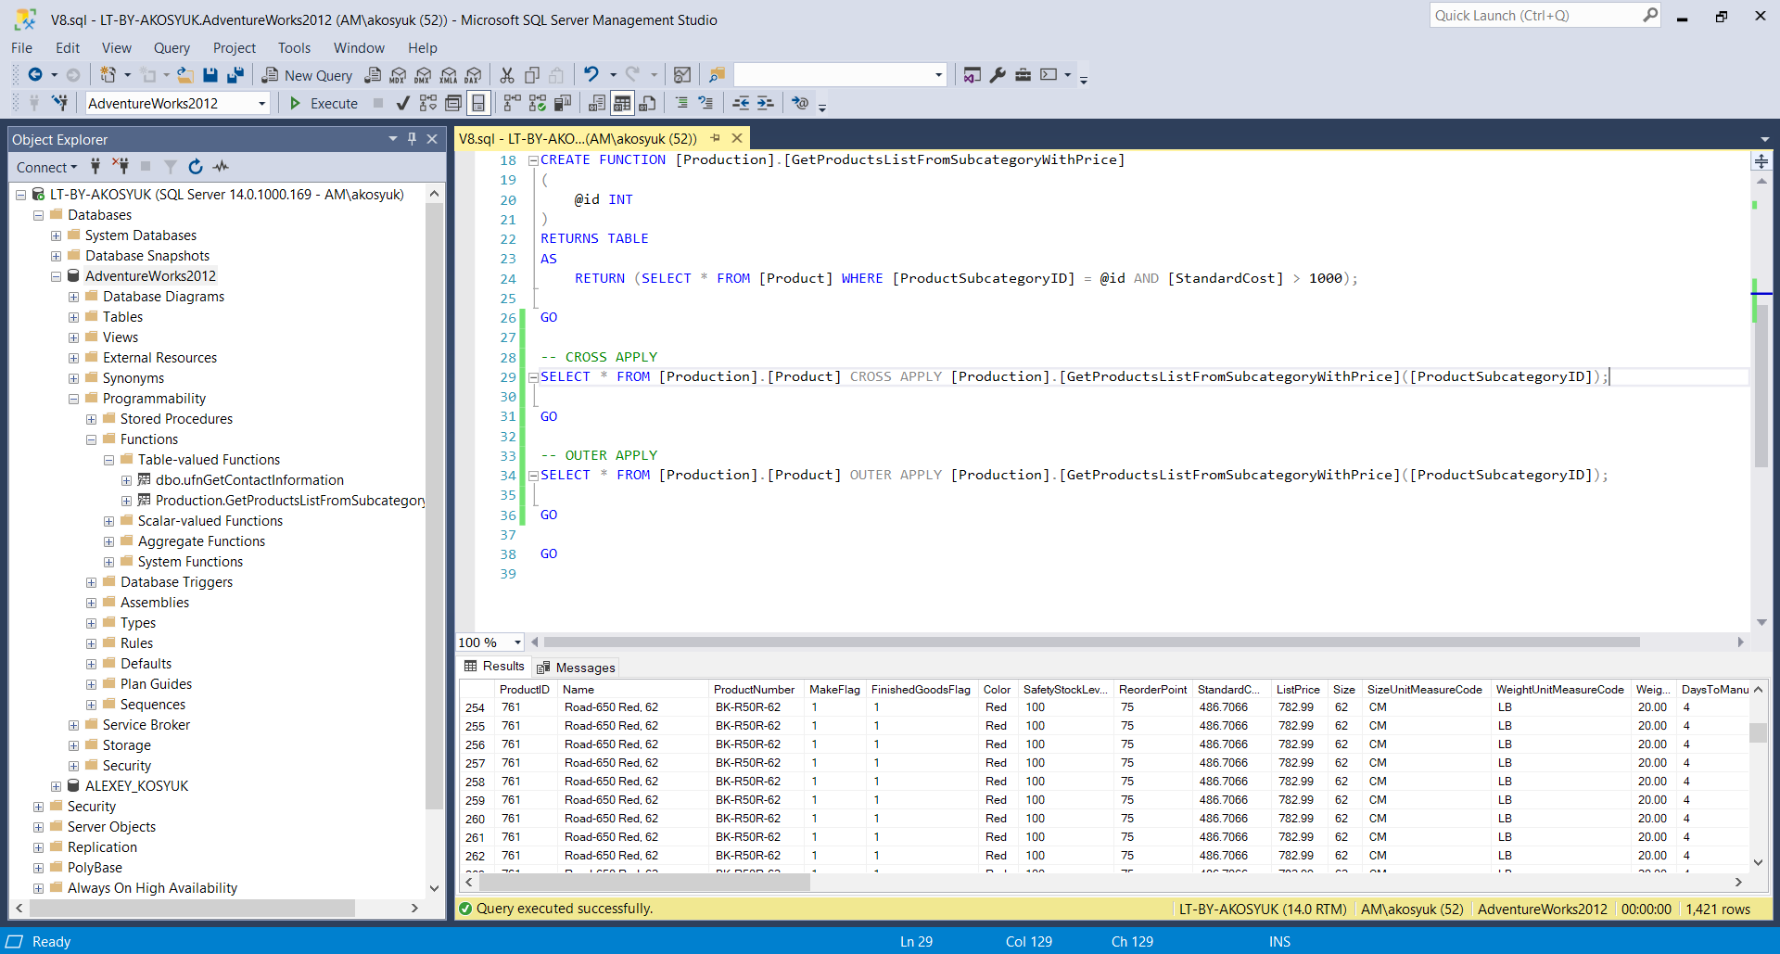

4. OUTER APPLY:

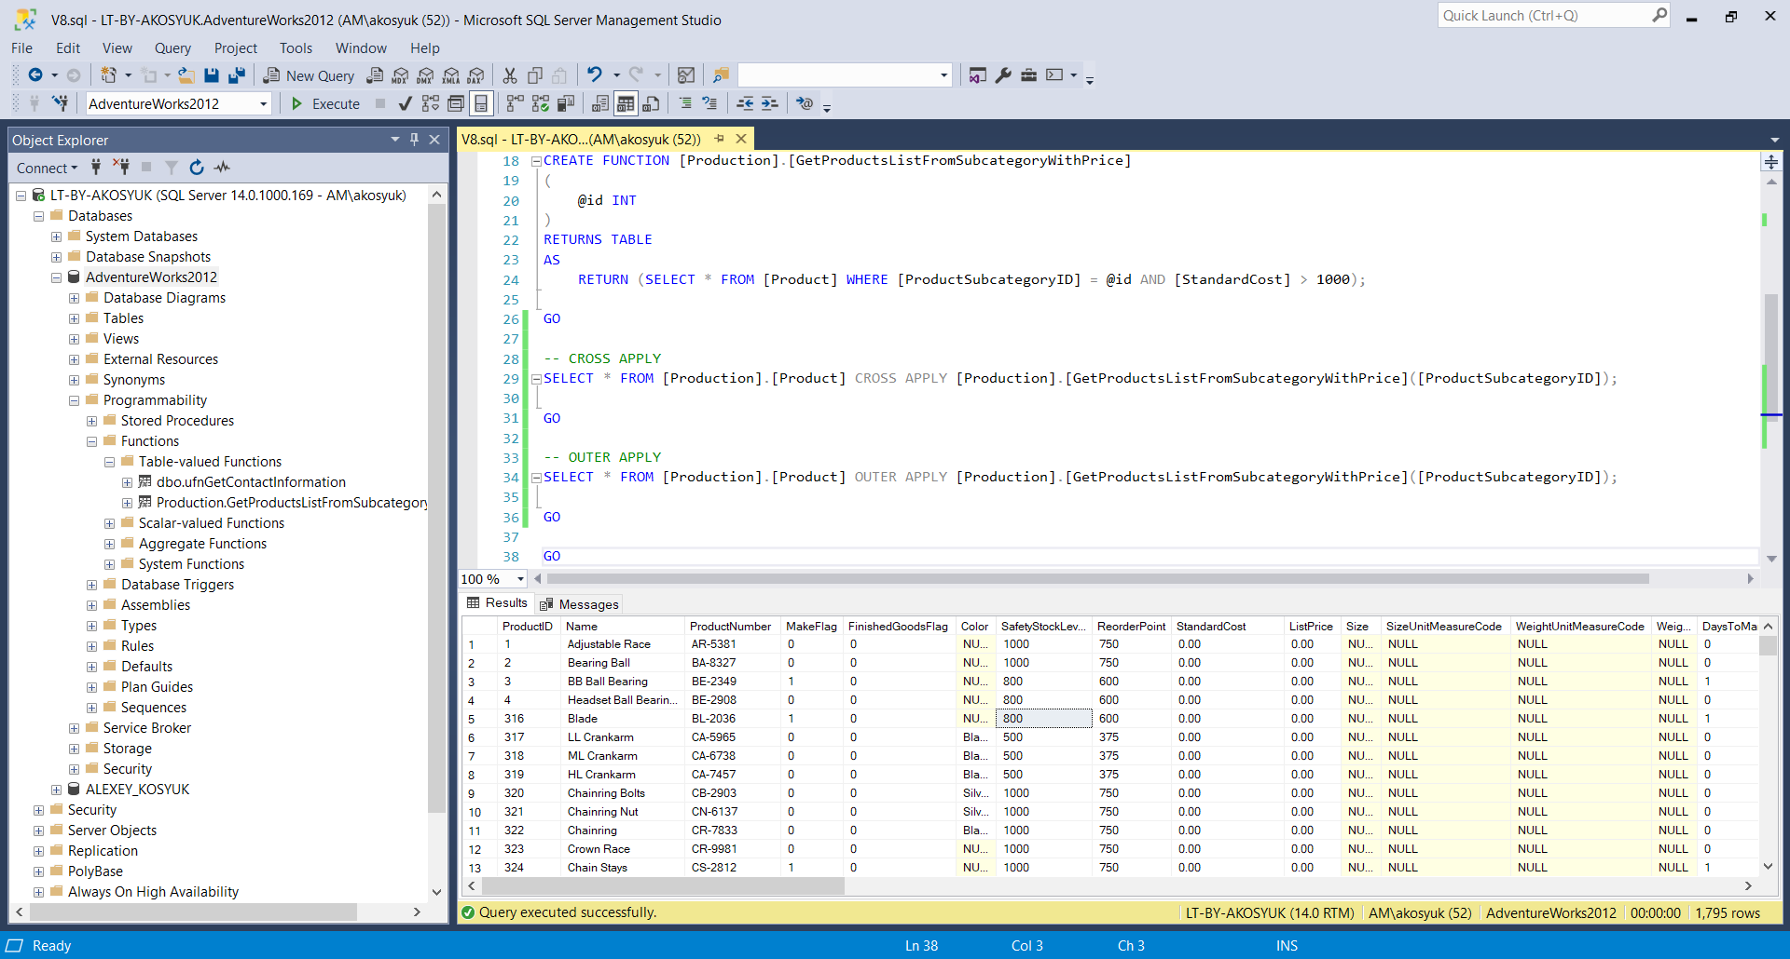

5. Multistatement table-valued:

